 **DELHI WORLD PUBLIC SCHOOL**

**BHATAPARA – BALODA BAZAR**

**(A Senior Secondary School Affiliated to C.B.S.E. New Delhi)**

**Grade-IV**

**Practical Exam**

1. Create a folder with name Scratch.

2. Create a file with you name in the folder Scratch.

3. Be good, Do good

Eat food, Be good

Replace the good with great

**Teddy bear, Teddy bear**

**Turn around**

**Teddy bear, Teddy bear**

**Touch the ground.**

4.

5. Make any poster using Shapes and pictures.

**DELHI WORLD PUBLIC SCHOOL**

**BHATAPARA – BALODA BAZAR**

**(A Senior Secondary School Affiliated to C.B.S.E. New Delhi)**

**Grade-V**

**Practical Exam**

1. Create the following table-

And calculate the sum using formula.

|  |  |  |
| --- | --- | --- |
| S.No | Items | Quantity |
| 1 | Mouse | 18 |
| 2 | Scanner | 20 |
| 3 | Keyboard | 30 |
| Total Quantity- | |  |

2. Create the following table-

|  |  |  |
| --- | --- | --- |
| Delhi World Public School | | |
| Class | Student Name | Marks |
| V | Joy | 58 |
| 96 |
| Tom | 45 |
| 64 |

3. Use Mail merge to Mail the document-

4. Start the screen recording and

i) Make a photo album ii) Use Ink annotation



**DELHI WORLD PUBLIC SCHOOL**

**BHATAPARA – BALODA BAZAR**

**(A Senior Secondary School Affiliated to C.B.S.E. New Delhi)**

**Grade-VI**

**Practical Exam**

1. Create a new desktop.

2. Show Flash Fill feature.

3.Show months name with the help of Auto Fill feature.

4.Make the following table in Excel-

4A 4B

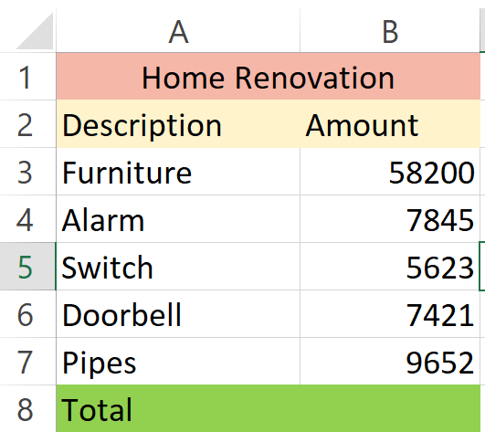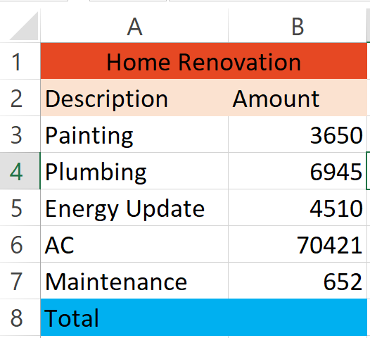



**DELHI WORLD PUBLIC SCHOOL**

**BHATAPARA – BALODA BAZAR**

 **(A Senior Secondary School Affiliated to C.B.S.E. New Delhi)**

**Grade-VII**

**Practical Exam**

1. Represent the data in the form of chart and sort it alphabetically -

A B

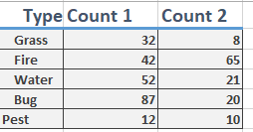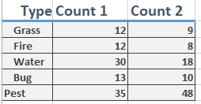

2. A Flip an image using GIMP.

2. B Rotate an image using GIMP.

3. A Write am HTML code for-

A B

